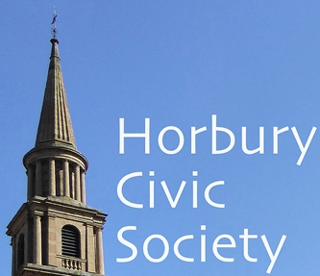
horbury civic society
www.horburycivicsociety.org.uk
Charity No: 255238

Membership Application Form 2024
The aims of the Society are:
- To encourage high standards of architecture and town planning in the township of Horbury
- To stimulate public interest in and care for the beauty, history, and character of Horbury
- To encourage the preservation, development, and improvement of features of public amenity or historic interest
- To pursue these ends by means of meetings, exhibitions, lectures, and promotions of schemes of a charitable nature.

Annual membership subscription for 2024
- Individual £10.00
- Unwaged/retired £ 8.00
- Joint (two adults at the same address) £18.00 NOW JUST £5.00
- Voluntary donation £
- Cheques/payments should be made payable to Horbury Civic Society and sent to:
- HCS, 11 Dovecote Lane, Horbury, WF4 6BG.
- Alternatively you can make a BACS payment using
- Sort code: 08-92-99 Account: 65839452 and Ref:HCSmmbr

name(S): *

signature(S):* DATE:*

address:
___________________________________________________________________________________________
___________________________________________________________________________________________
Phone: ___________________________________________________________________________________________
Email: * ___________________________________________________________________________________
- Your data: we only collect the data on this form so that we can communicate with you.
- We do not share your data with others.
- Contact us at – info@horburycivicsociety.org.uk or call 01924 374293

